The SAUVC competition challenges participant teams to build an AUV which can perform given tasks. These tasks are simulations of tasks operational AUVs would have to be able to perform. The competition is held in a swimming pool and each team's AUV will have to perform 4 tasks. The speed and accuracy at which the AUV performs tasks will be used to decide the winner of the competition.

The tasks involve four widely faced challenges underwater such as **AUV navigation, visual identification, acoustic localization and robotic manipulation.**

The competition is open to participants from all over the world. A team may consist of up to 8 participants. At least half of the participants must be students at the time of registration or 11 participants including faculty supervisor with at least half of the team member students at time of registration.

## Score

|  |  |  |  |
| --- | --- | --- | --- |
| AUV Bonus | Max size 140 × 100 × 100 cm  Less than 70 cm × 50 cm × 50 cm (BONUS)  MAX weight 50kg in air  Less than 40 kg weighed in air  (BONUS) | No points  +10(bonus)  No points  +10(bonus) |  |
| Task 1 - Navigation | Pass through the gate | +10 |  |
| Task 2 - Target Acquisition | Drop the ball in the blue drum  Drop the ball in the red drum with the pinger  Drop the ball in any other red drum  None | +30  +50  +10  0 |  |
| Task 3 - Target Reacquisition | Pick up the ball and hold on to it | +60 |  |
| Task 4 - Localisation | Knock the ball off the flare | +40 |  |
| Timing bonus | End of attempt (breach the surface)  Timing Bonus (If end of attempt + 2 successful tasks) | +5  (900 - 0) * 0.03 = +0 | s |
| Penalties | Touch the gate  Touch the bottom of the pool or wall | -2  -5 |  |

## Video Submission

All teams have to submit a video of their AUV prior to the competition. The video has to

* be maximum 5 minutes long,
* be submitted before December 31.
* showcase the AUV swimming underwater for at least 10 seconds.
* showcase the operation and safety of the [Kill Switch](https://sauvc.org/rulebook/#safety).

Videos will be reviewed by the organizing committee and only teams with accepted videos be allowed to attend the competition.

## The Arena

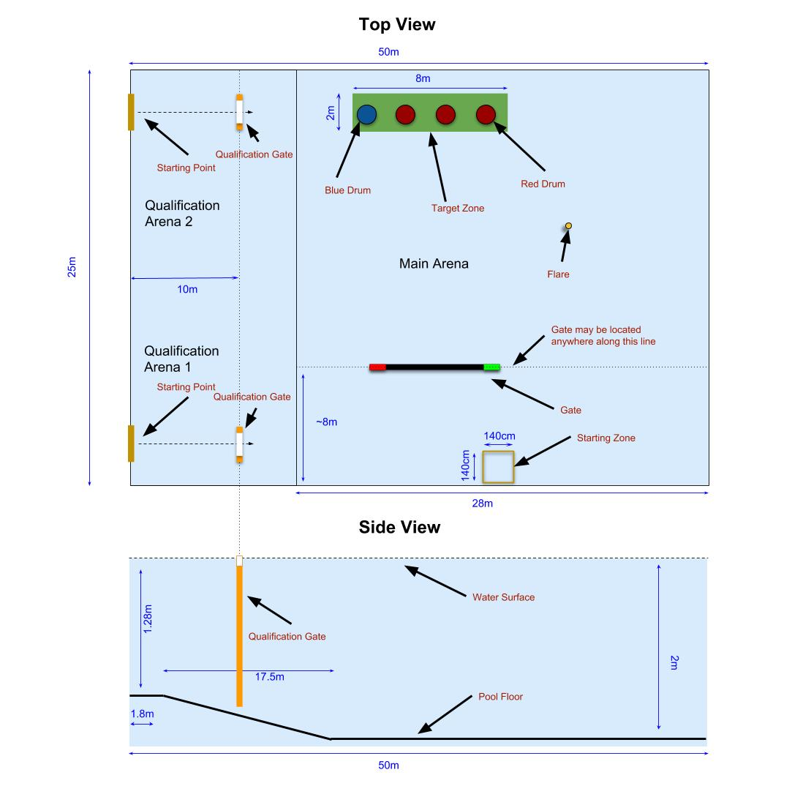

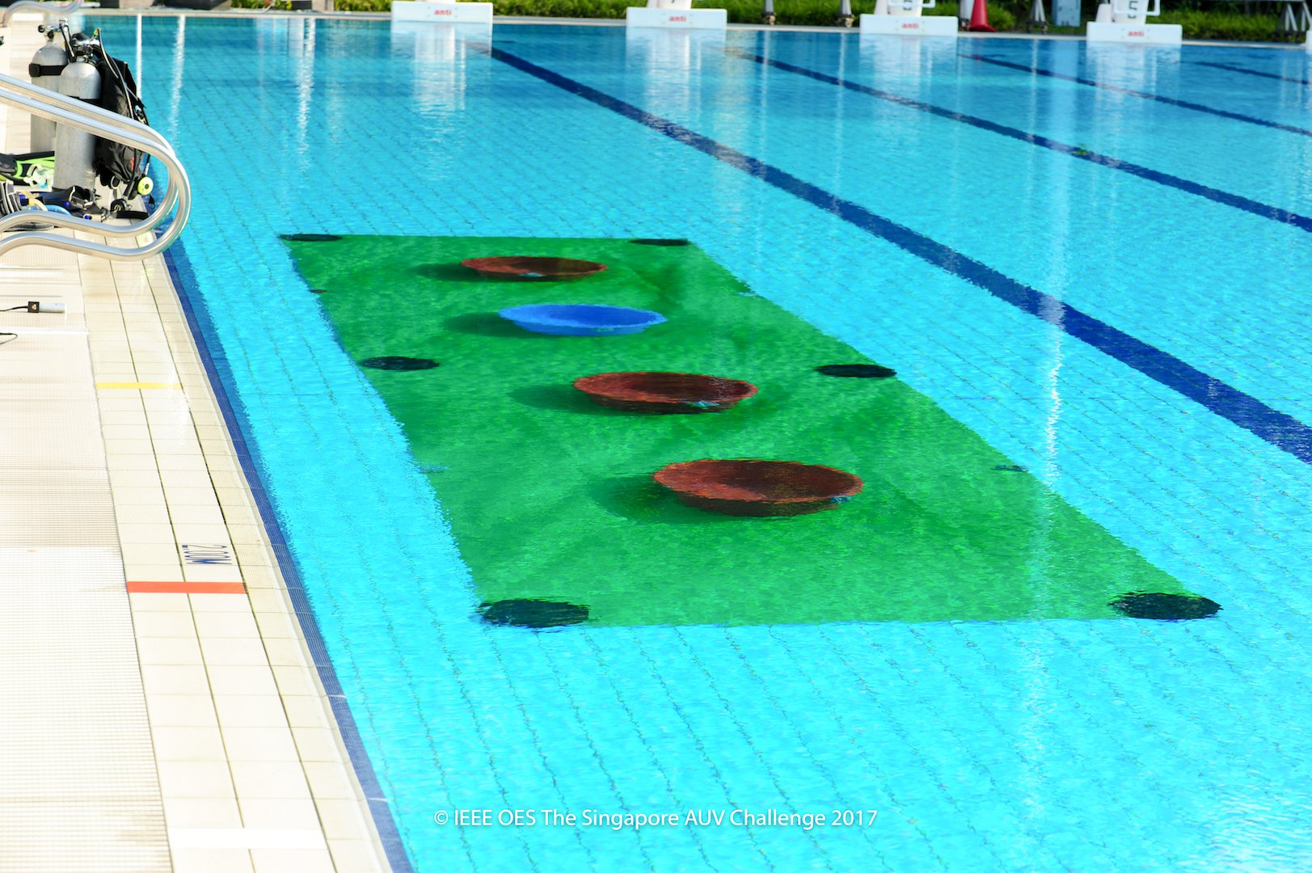

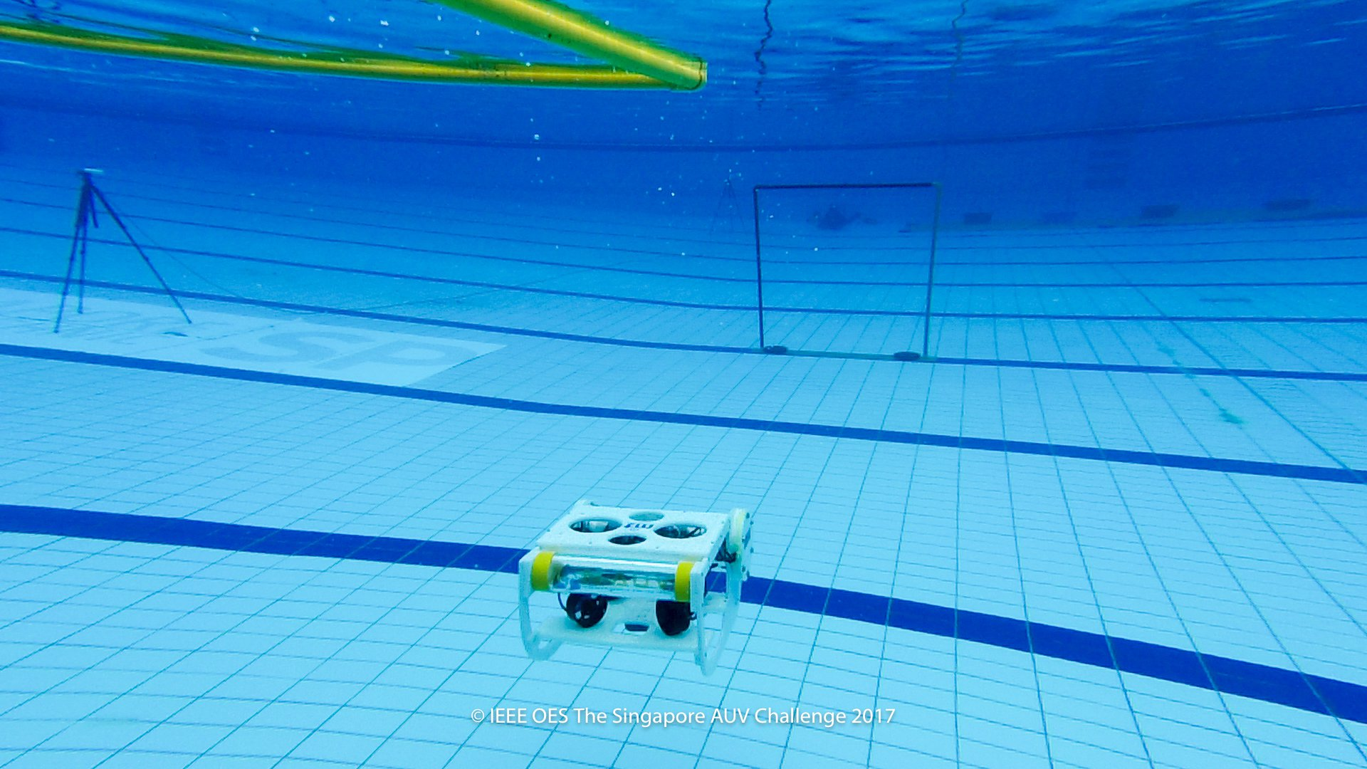

## Qualification/Main Arena(s)

The qualification rounds would be held on the side of the main arena.

The qualification starting line is a **marked 1m wide** section of the pool wall from where the AUV should be deployed from. The AUV has to touch the wall at the beginning of the run.

At approximately 10m from the starting line the qualification gate is hanging from the surface of the water. The AUV has to go through the gate to qualify.

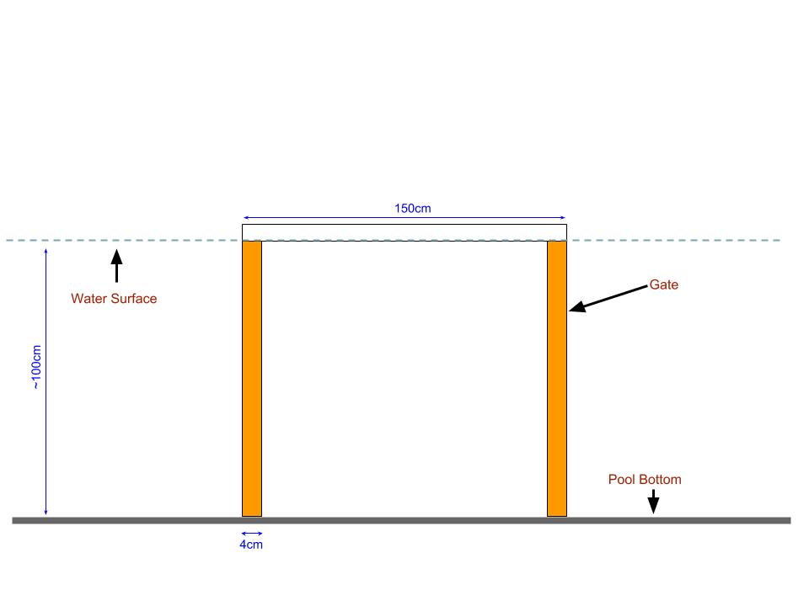

150cm wide and ~100cm deep gate hanging from the water surface with orange markings on both port and starboard sides.

### Starting Zone

The starting zone is a 140×140cm area marked on the surface of water. The teams must start their AUVs from this area. The team may only place the AUV at the water surface, it must autonomously submerge before leaving the starting zone.

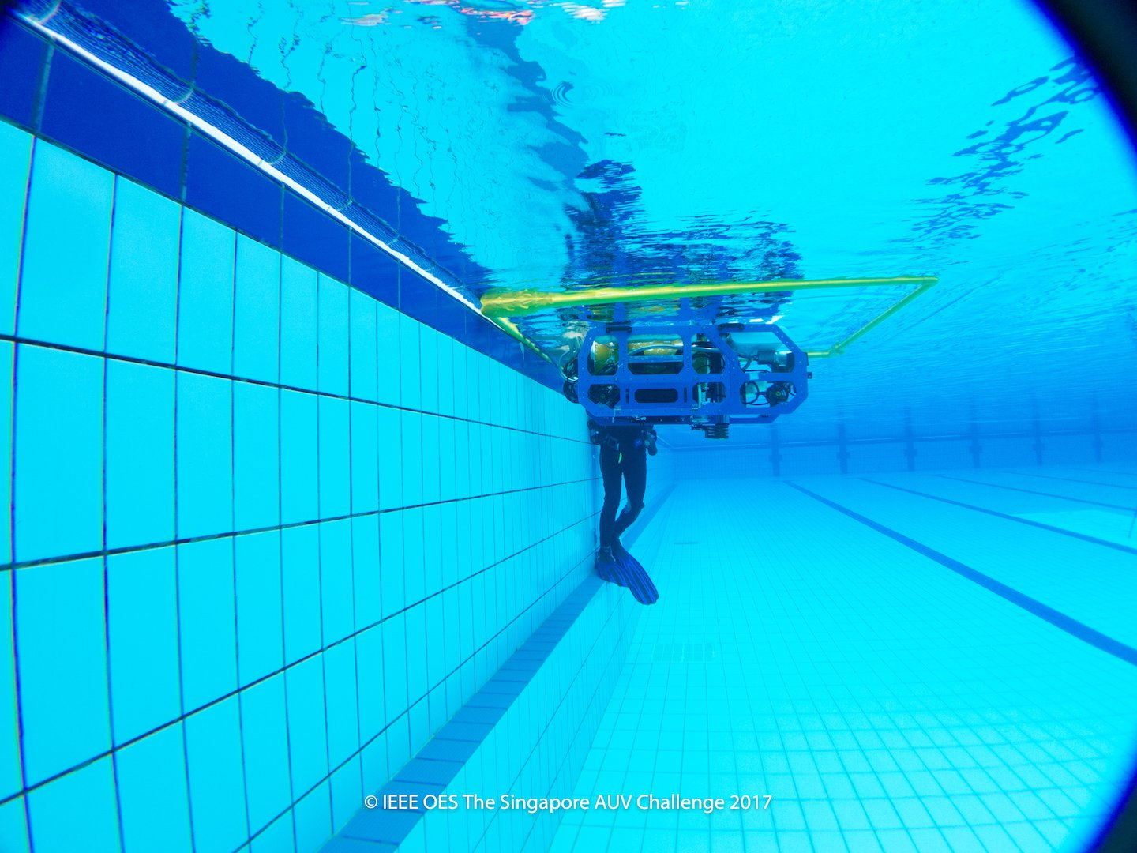

### Tasks

There are 4 tasks in the challenge:

1. [Navigation](https://sauvc.org/rulebook/#1.-navigation)
2. [Target Acquisition](https://sauvc.org/rulebook/#2.-target-acquisition)
3. [Target Reacquisition](https://sauvc.org/rulebook/#3.-target-reacquisition)
4. [Localization](https://sauvc.org/rulebook/#4.-localization)

The first task, Navigation, is mandatory and must be completed before attempting any other task. The other tasks can be attempted in any order. Surfacing at any point signifies end of attempt.

### 1. Navigation

The aim of this task is to swim through a gate in water. The gate may be located anywhere on a horizontal line, parallel to the side of the swimming pool, approximately 8m away from the starting point. The AUV has to swim through the 150 cm high gate without touching the gate.

How to achieve :

After submerging , we first need to locate the gate*(Qualification round gate has orange colored side poles whereas main arena gate has green and red colored side poles)* through IP by rotating the bot in different direction and checking with each movement. First we need to check the gate location when it is submerged.

Since left side pole is red and right one is green. We can first check for gate as soon as it get submerged . now depending on the detected color we can rotate the bot in the direction:

* + - 1. Say only red color is detected , this means we need to rotate and traverse in right direction.
      2. If green is detected , we need to rotate and move in left direction and then align in direction in front of the bot.
      3. If both the color are detected then based on the distance of contours of each color pole ,if red pole is closer then move in right else if green pole is closer then move in left.

Either we can move the bot directly in the direction of gate or we can first align the bot to face the gate *(the bot to be in region of normal vector of gate)* and then move towards it.

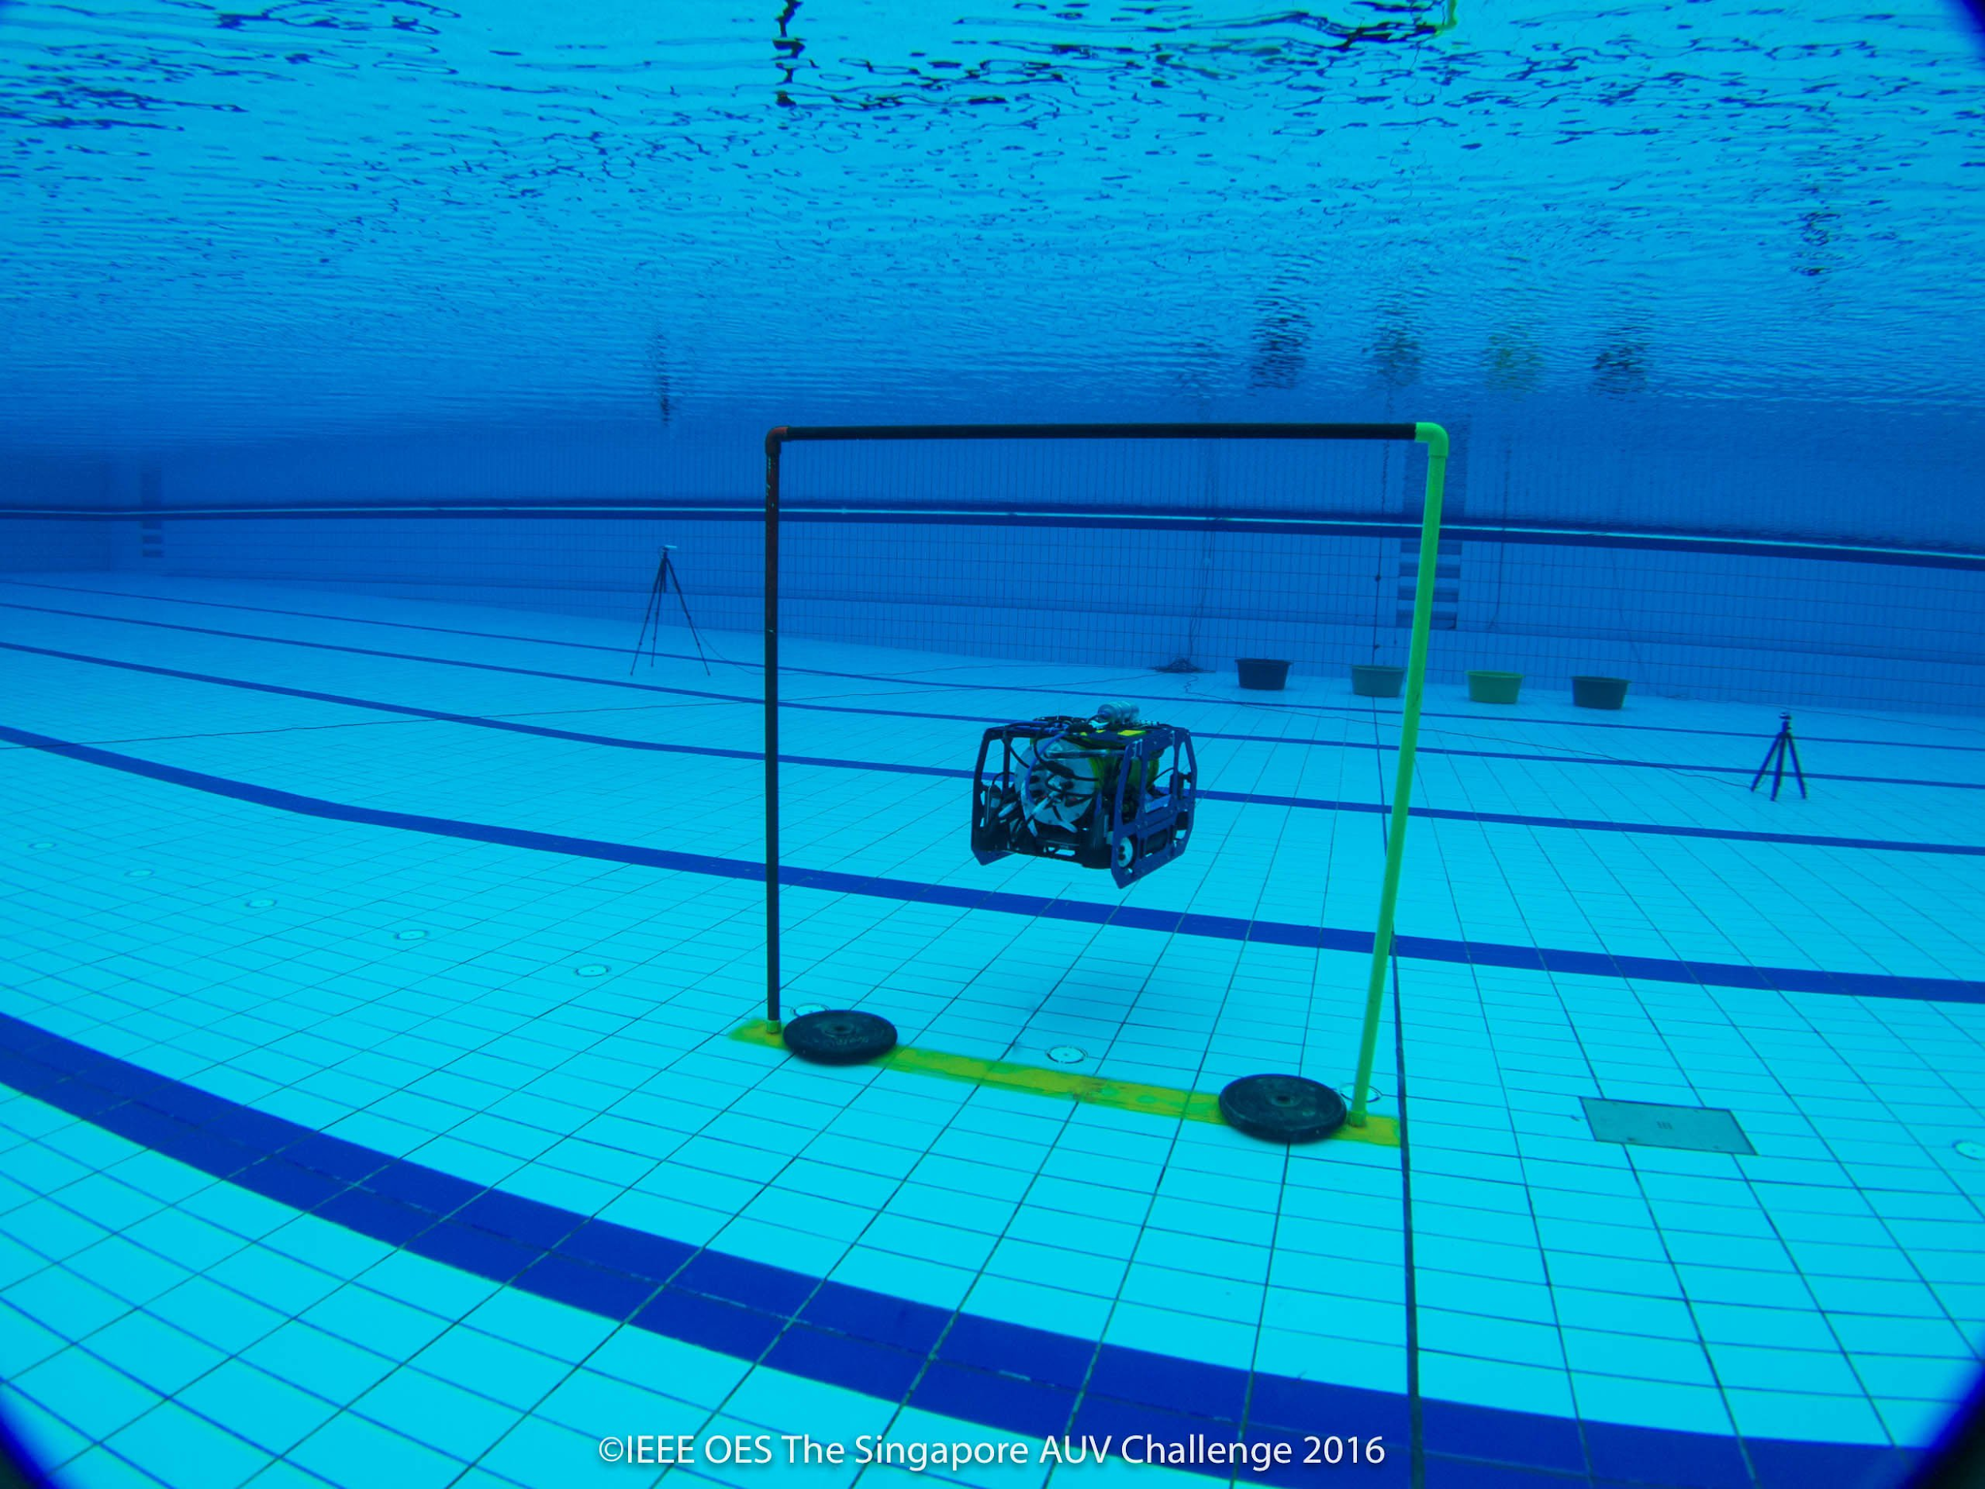

150cm wide and 150cm high gate with red and green markings on port and starboard sides respectively.

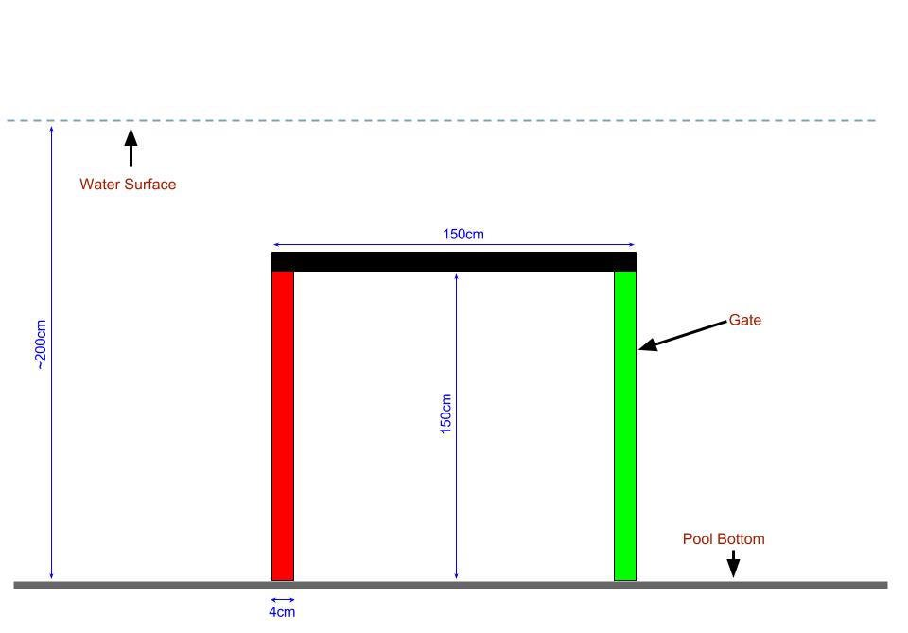

### 2. Target Acquisition

The aim of the task is to detect and acquire a target among a series of drums at the bottom of the pool, in the target zone.

A target zone is defined by a green colored mat laid out on the floor of the pool. The mat is 8m x 2m in size .

There are 4 colored drums in the arena. All of them are on the mat. One of the drums, chosen at random, will be blue in color, while the rest are red in color. One of the red drums, chosen at random, will contain an acoustic pinger. The AUV needs to drop a ball in one of the drums to successfully complete this task. Points will be awarded based on which drum the ball is dropped into. In the event of multiple balls being dropped, only the first ball is taken to consideration.

The location of the red drum which contains the acoustic pinger may be randomized between attempts, as may be the order of the drums. The order of the drums and location of the pinger will be decided by the organizing committee.

Points will be awarded as follows.

* Drop the ball in the blue drum: 30 Points
* Drop the ball in the red drum with the pinger: 50 Points
* Dropping the ball in any other red drum: 10 Points

|  |  |  |
| --- | --- | --- |
|  | Prop | Description |
| 1 | Drum | 60cm in diameter and 30cm in depth. |
| 2 | Ball | 3.5-4.5cm in diameter and weigh no more than 200g in air. Provided by teams. |
| 3 | Drum Pinger | [RJE International Pinger Model No. ULB-362B/45 kHz](http://www.rjeint.com/wp-content/uploads/2017/01/ULB-362-ULB-362PL-Manual.pdf). |

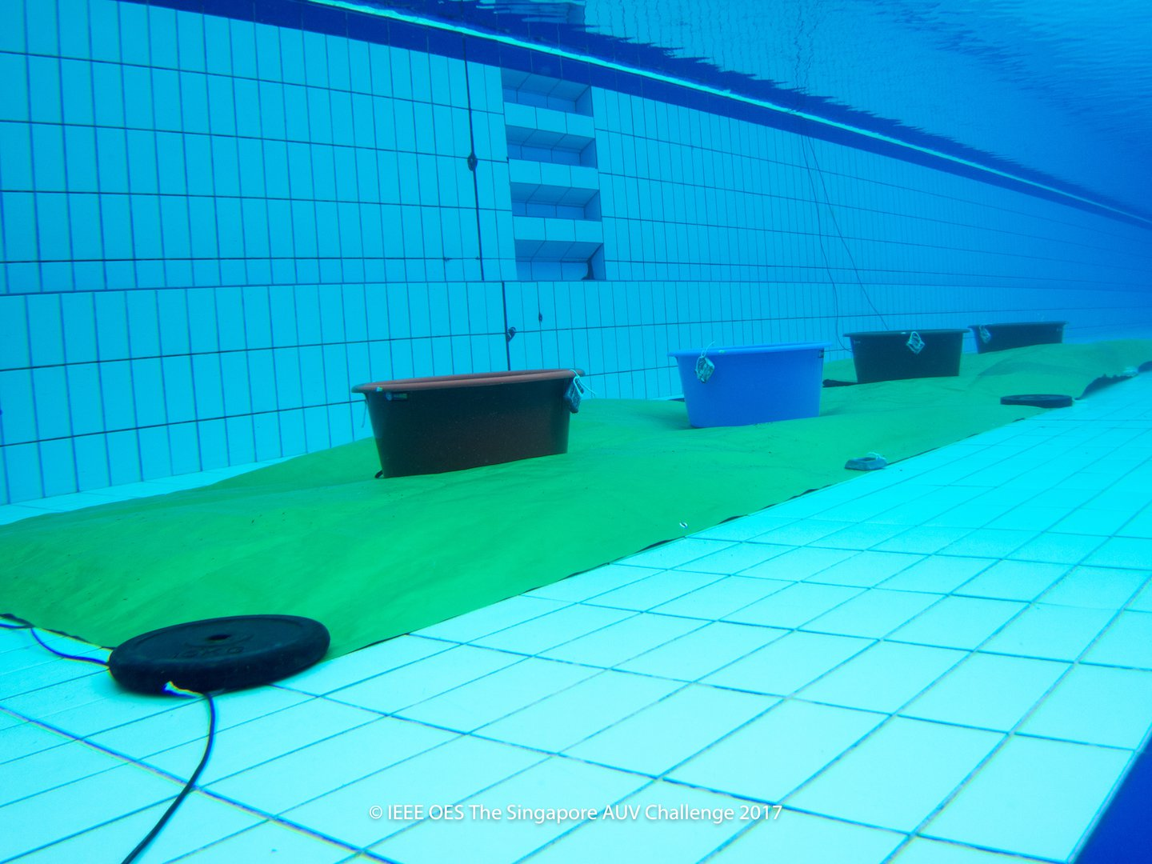

How to achieve :

After passing through the gate , we need to detect the green mat which is laid on floor.

So for that we need to tilt the bot in downward direction to detect object on the floor which can be achieved either by using bottom camera or front camera.

### 3. Target Reacquisition

The aim of this task is to reacquire a previously detected target.

This task is only attemptable if the [Target Acquisition](https://sauvc.org/rulebook/#2.-target-acquisition) has been successfully completed. Furthermore, the AUV has to leave the target zone, before it can attempt the Target Reacquisition task. Every part of the AUV needs to clear the target zone, before it can be considered outside the target zone.

After the AUV is outside the target zone, it needs to reacquire the target and pick up the ball that it dropped in the [Target Acquisition](https://sauvc.org/rulebook/#2.-target-acquisition) task. The AUV has to hold on to the ball till the end of attempt to successfully complete this task.

This task does not have to be attempted immediately after Target Acquisition task, other tasks may be attempted in between.

#### Points

If the AUV successfully picks up the ball and holds on to it till the end of the attempt, 60 Points will be awarded.

#### Specification of props

|  |  |  |
| --- | --- | --- |
|  | Prop | Description |
| 1 | Target zone | Green mat 8m x 2m in size. |
| 2 | Ball | Same ball used in target acquisition task. Provided by the teams. |

### 4. Localization

The aim of this task is to localize on a flare. The flare is marked with an acoustic pinger. This flare could be located anywhere within the main arena. The AUV should locate and bump the flare causing the golf ball on the flare to drop out. The flare will be yellow in color.

#### Points

If the AUV successfully causes the ball to drop from the flare, 40 Points will be awarded.

#### Specification of props

|  |  |  |
| --- | --- | --- |
|  | Prop | Description |
| 1 | Flare | 80cm high and yellow in color. |
| 2 | Flare Pinger | [RJE International Pinger Model No. ULB-362B/37.5 kHz](http://www.rjeint.com/wp-content/uploads/2017/01/ULB-362-ULB-362PL-Manual.pdf). |

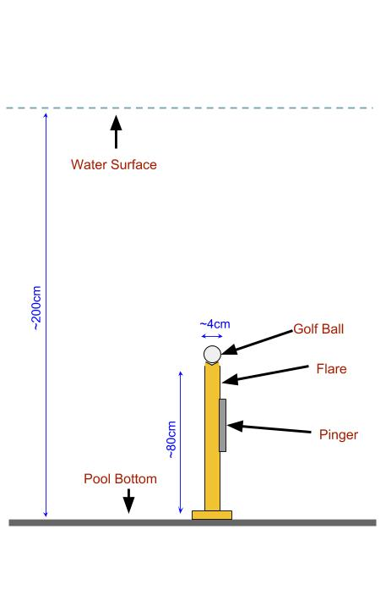

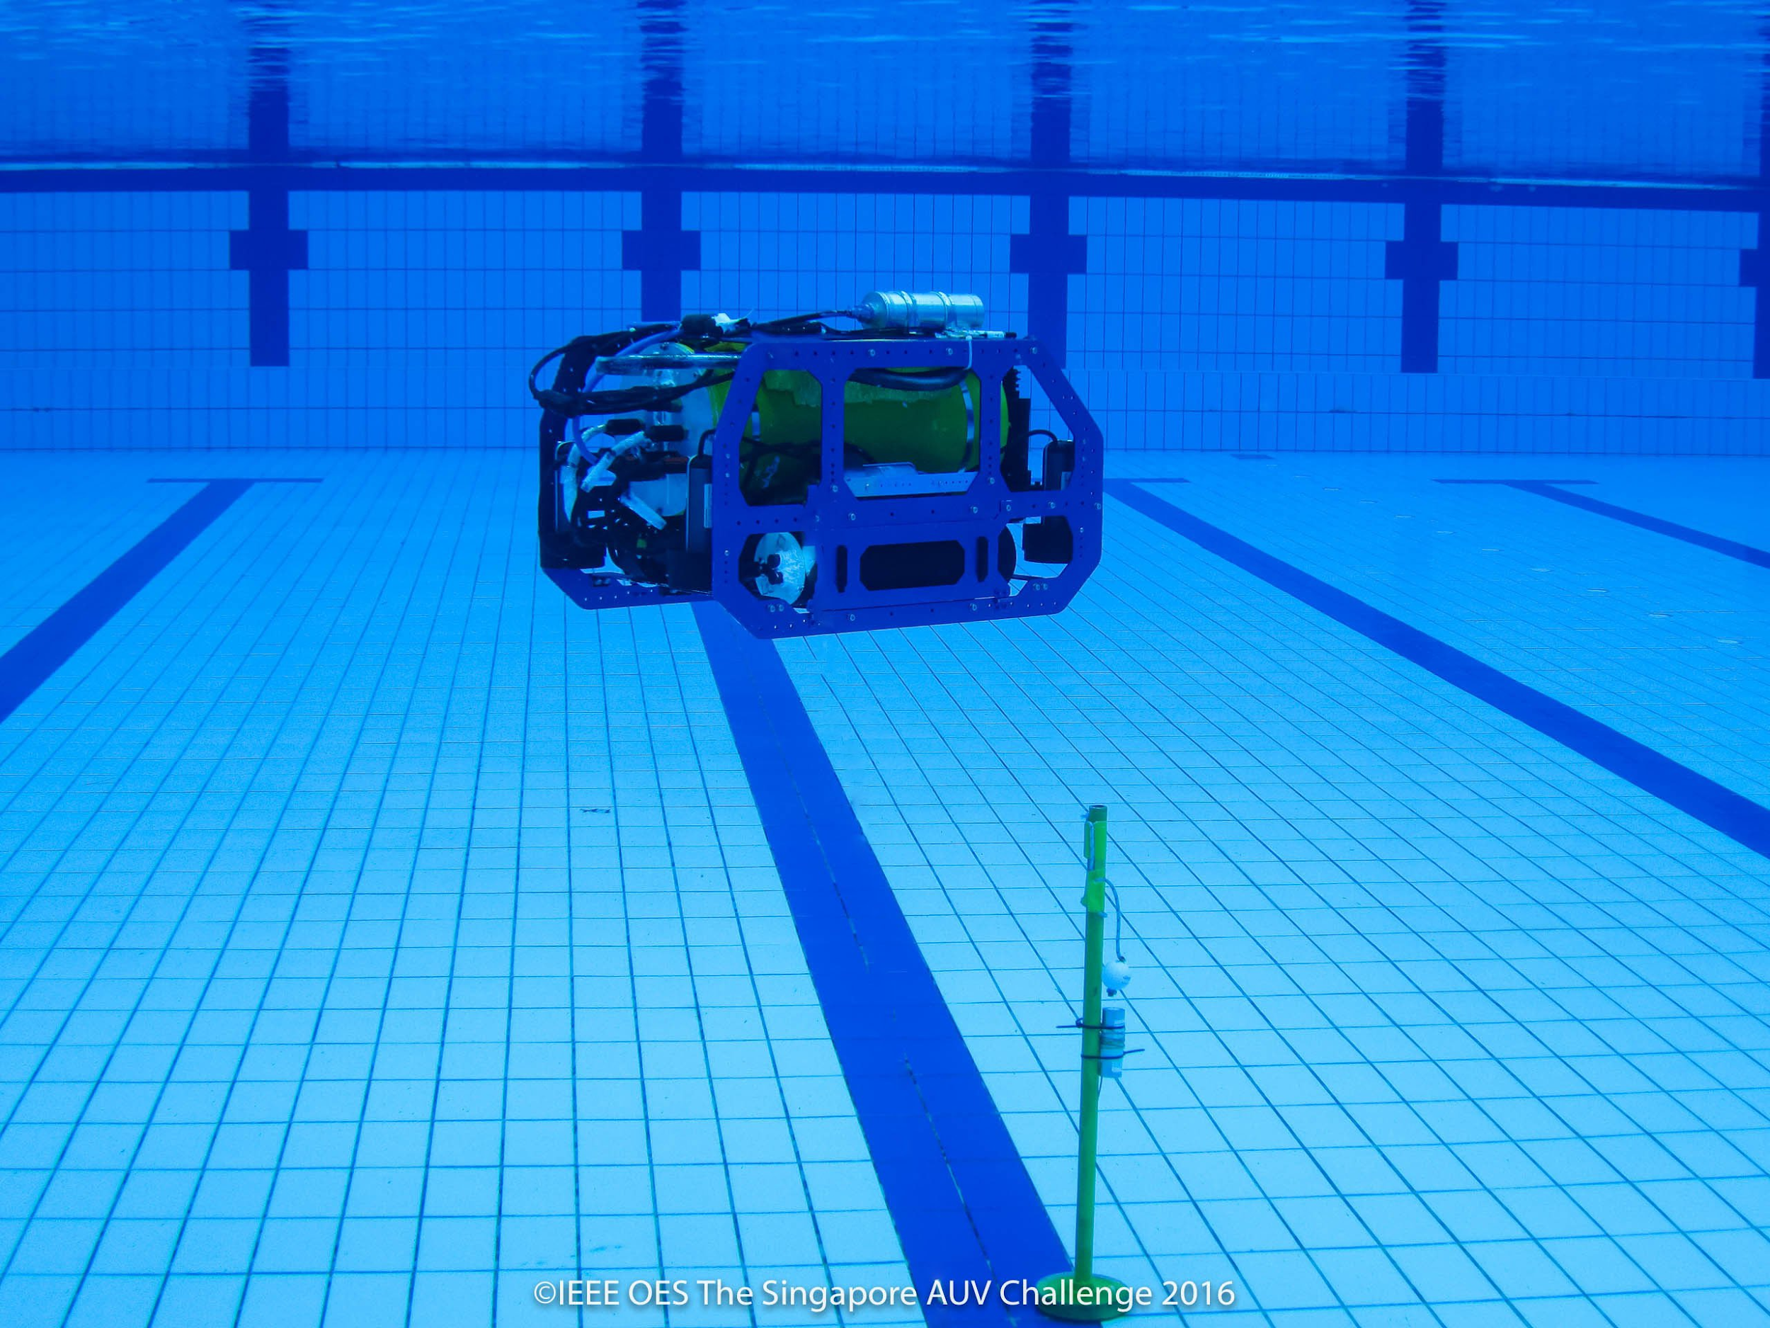

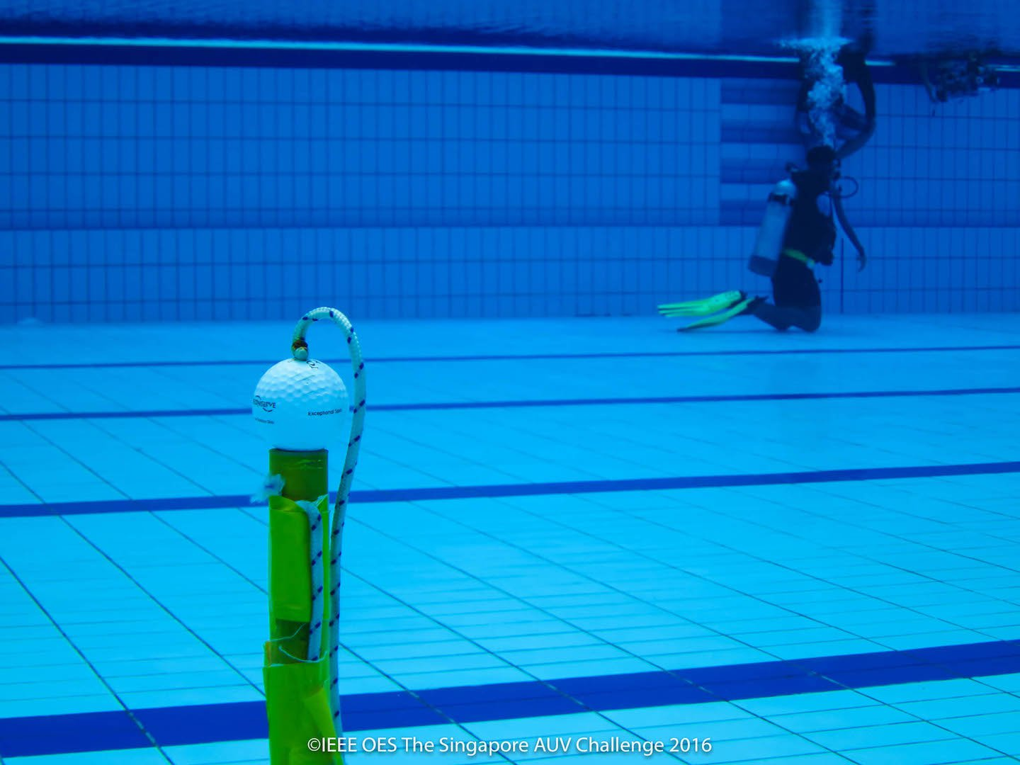

### Surfacing

Breaching the surface any point during the mission causes end of the current attempt, the total points for that attempt will be computed based on the tasks accomplished in that attempt and the timing bonus (if applicable) and a 5 Points bonus for ending. The team may wish to retry if they still have time left.

### Aborting

At any time during the mission, current attempt can be aborted, by indicating to the Game Master. The divers would then retrieve the AUV back to the starting zone. The timing for the current attempt is stopped at the time of indication. The team may wish to retry if they still have time left.

In the case of an aborted attempt, the team would be awarded the points for all previously successfully completed tasks during the current attempt.

### Automatic Abort

If the AUV touches the bottom or the side walls of the pool for a cumulative time of more than 10 seconds or 5 discrete touches, the current attempt would be automatically aborted. The divers would then retrieve the AUV back to the starting zone. The team may wish to retry if they still have time left.

In the case of an automatic aborted attempt, the team would be awarded the points for all previously successfully completed tasks during the attempt.

### 